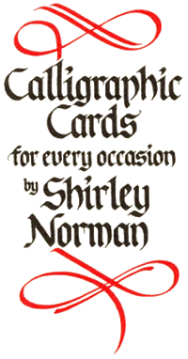
ORDER FORM
UK JANUARY 2012 220102010-03-16 22222020072007-10-2 2007

COMPANY
ADDRESS

POSTCODE
TELEPHONE FAX
DATE
CONTACT NAME
EMAIL
INVOICE TO (If different from above)

POSTCODE
DELIVERY DATE
To keep paperwork to a minimum invoice is included with order

PLEASE SUPPLY THE GOODS AS INDICATED. I / WE HAVE READ AND AGREE TO THE TERMS OF TRADING
SIGNATURE
NAME IN PRINT
If paying by Credit Card the following details are required
CARD NUMBER
START DATE EXPIRY DATE
CARD SECURITY CODE
CARD HOLDER’S POST CODE
ADDRESS TO WHICH CREDIT CARD STATEMENTS ARE SENT

TELEPHONE NUMBER AT ABOVE ADDRESS
EMAIL : Scribe@CalligraphicCards.co.uk
Internet : http://www.CalligraphicCards.co.uk
Telephone : +44 (0) 1437 781775
PRICES
Prices are held for three months and are stated over -leaf. Please check for current prices thereafter.
Postage and packing free on all orders over £150 in the United Kingdom.
Orders under £150 post and packing £12.00
Minimum order : £50.
PAYMENT
Please make cheques payable to Calligraphic Cards or pay by credit card: we accept Visa or Mastercard.

TERMS OF TRADING
Pro Forma invoices on initial orders.
Payments of accounts must be made within 30 days from date of invoice.
Where reminders have to be issued a charge will be made of £10 for each reminder and all deliveries suspended until such accounts are cleared.
Claims for shortages or damaged cards can only be considered if notified in writing within 5 days of receipt. Goods cannot be accepted for exchange or return.

Title of goods supplied by Calligraphic Cards shall not pass to the customer until the purchase price has been received in full.

Calligraphic Cards are sold to the customer on the understanding and condition that they will not be offered for resale in any other form than a greeting card unless requested in writing.
Contact : Shirley Norman
2 Holbrook Close
Broad Haven, Haverfordwest
Pembrokeshire, SA623JE
United Kingdom
TELEPHONE : 01437 781775

